# Deep Vehicle Following-Caffe

By Alex, last modified on 2019/01/17

## Setup Steps

### Step1. Rosbag record

Run joystick and camera

**Duc****kiebot $ rosla****unch duckietown joystick_camera.launch veh:=****[robotname]**

Get image and car_cmd informations.

**Duck****ietop $ r****osbag record /[robotname]/camera_node/image/compressed /[robotname]/joy_mapper_node/car_cmd --spilt --size=2048 -o [name].bag**

**Ctrl+C to stop**

Then you will get a [name].bag

Use bag2txt.py draw out the image and car_cmd value.

For more information you can see bag2.txt.

**Duckietop $ python bag2txt.py**

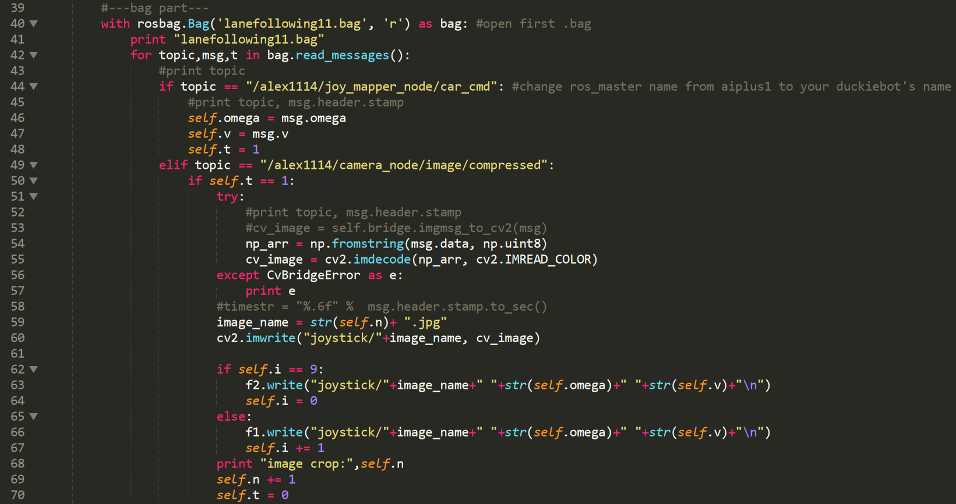

### Step2. Training by Caffe

# **此為Multi-Label的ＬＭＤＢ輸入格式(需依照以下方式更改caffe)**

[**https://blog.csdn.net/sushiqian/article/details/78771546?fbclid=IwAR2ZWLl-0JwDCCgEbG02_fMrWOcfw0U2U7BIKwX6q4xbe4tMfaAfETYuwE8**](https://blog.csdn.net/sushiqian/article/details/78771546?fbclid=IwAR2ZWLl-0JwDCCgEbG02_fMrWOcfw0U2U7BIKwX6q4xbe4tMfaAfETYuwE8)

1. put the folder with images into 'images' under 'for_ncs', and move the train.txt & test.txt to 'splits' folder under 'for_ncs'

2. after setup the environment, run 'python train.py' to start the training, more info in the train.py

3. after the training is done, there'll be a file called solvertemplate_iter_100000.caffemodel under for_ncs/results/0/snapshots/

/for_ncs/src/settings.py 內要更改caffe路徑

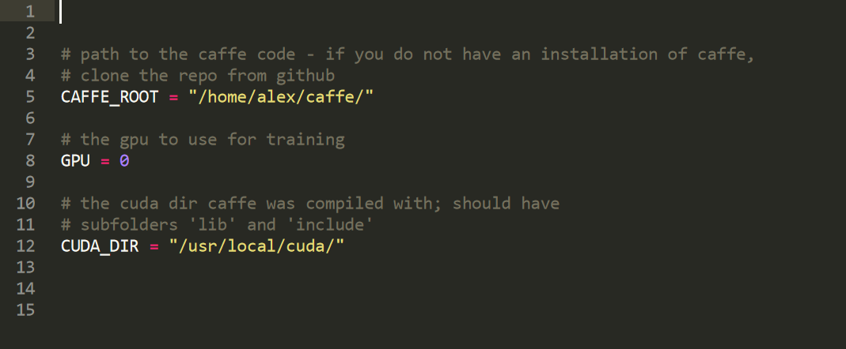

### Step3. Transform .caffemodel into .graph (need NCS)

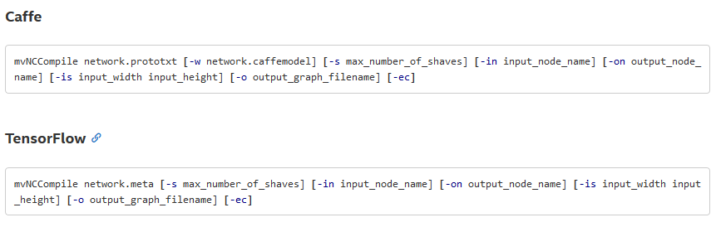

**Duckietop $ mvNCCompile /** **deploy.prototxt –w /[name].caffemodel -o /[name].graph**

### Step4. Move to Duckiebot (need NCS)

**程式碼目前在dockiebot上，由於目前不在新竹  
待1/24號再將此tutorial 補齊**

# **此為Multi-Label的ＬＭＤＢ輸入格式(需依照以下方式更改caffe)**

**https://blog.csdn.net/sushiqian/article/details/78771546?fbclid=IwAR2ZWLl-0JwDCCgEbG02_fMrWOcfw0U2U7BIKwX6q4xbe4tMfaAfETYuwE8**